

**Demeter Enabler Hub (DEH) User Manual**

  
  
Demeter is a Horizon 2020 project (857202) supported by the European Union.

About 3

Usage 3

Register 4

Login 6

Logout 8

Navigation through DEH 9

Add new DEH Resource 14

Edit DEH Resource 16

Delete DEH Resource 18

# About

The DEMETER Enabler HUB (DEH) s the digital space dedicated to end-users of DEMETER where they will be able to create and register their own resources. Users will have two roles and they will act as DEMETER Provider and DEMETER Consumer. A DEMETER Providers will be able to offer their resources (components, services, data sources, devices, platforms, etc), while DEMETER Consumers will be able to browse it and find suitable resources matching their requirements. Data entities from any Platform, Thing, Application, Service will be managed through these APIs, but for the sole purpose of discovery and management of the resource registry maintained by the DEH.

# Usage

Go to: <https://deh.h2020-demeter-cloud.eu/>

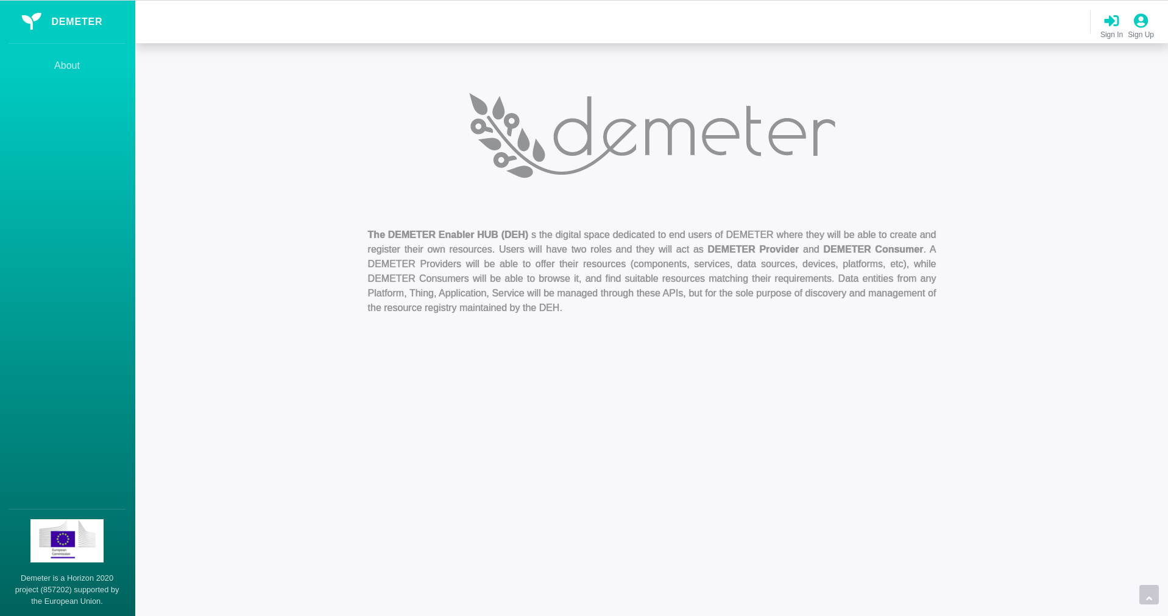  
  
*Figure 1. DEH Welcome Page*

In Figure 1. you can see the Welcome Page of DEH. If you want information about partners included in the development, you can click on About in the left navigation panel, as shown in Figure 2.

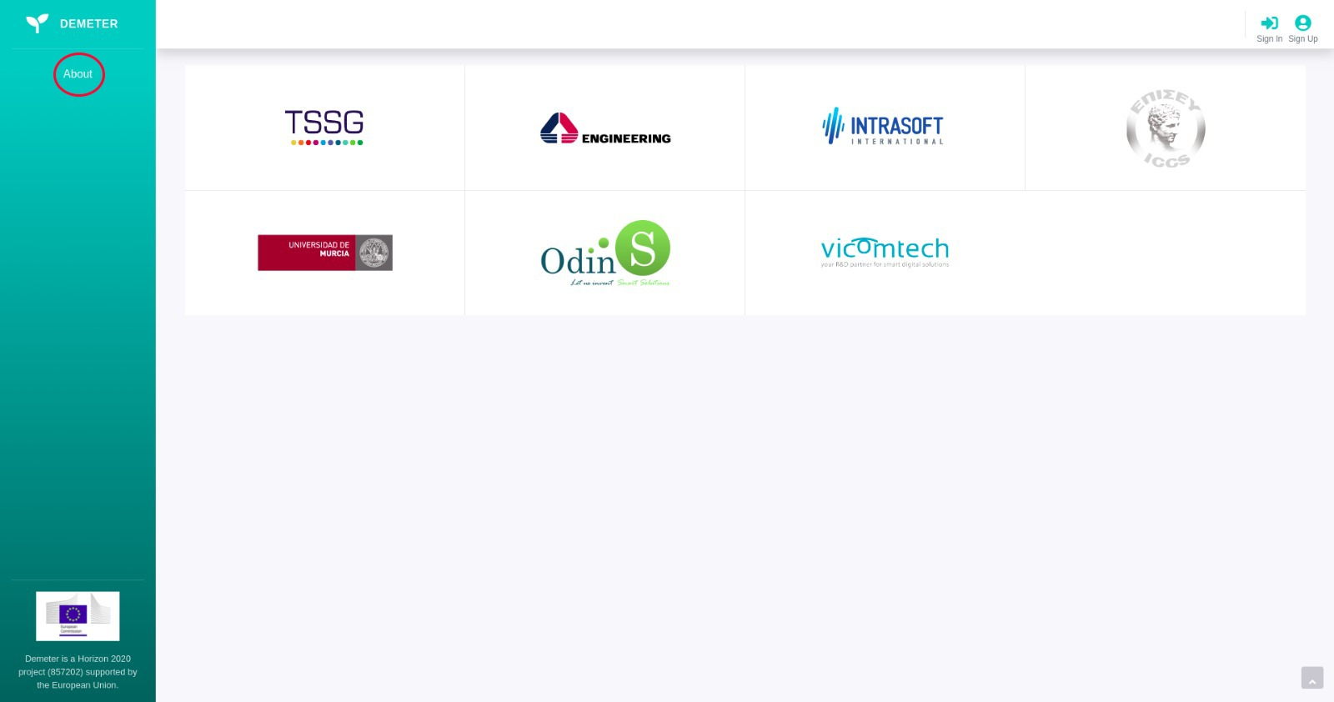

*Figure 2. DEH About Page*

## Register

If you want to create a new account for using DEH, follow the next steps:

1. Click on the Sign Up button in the right upper corner as shown in Figure 3.

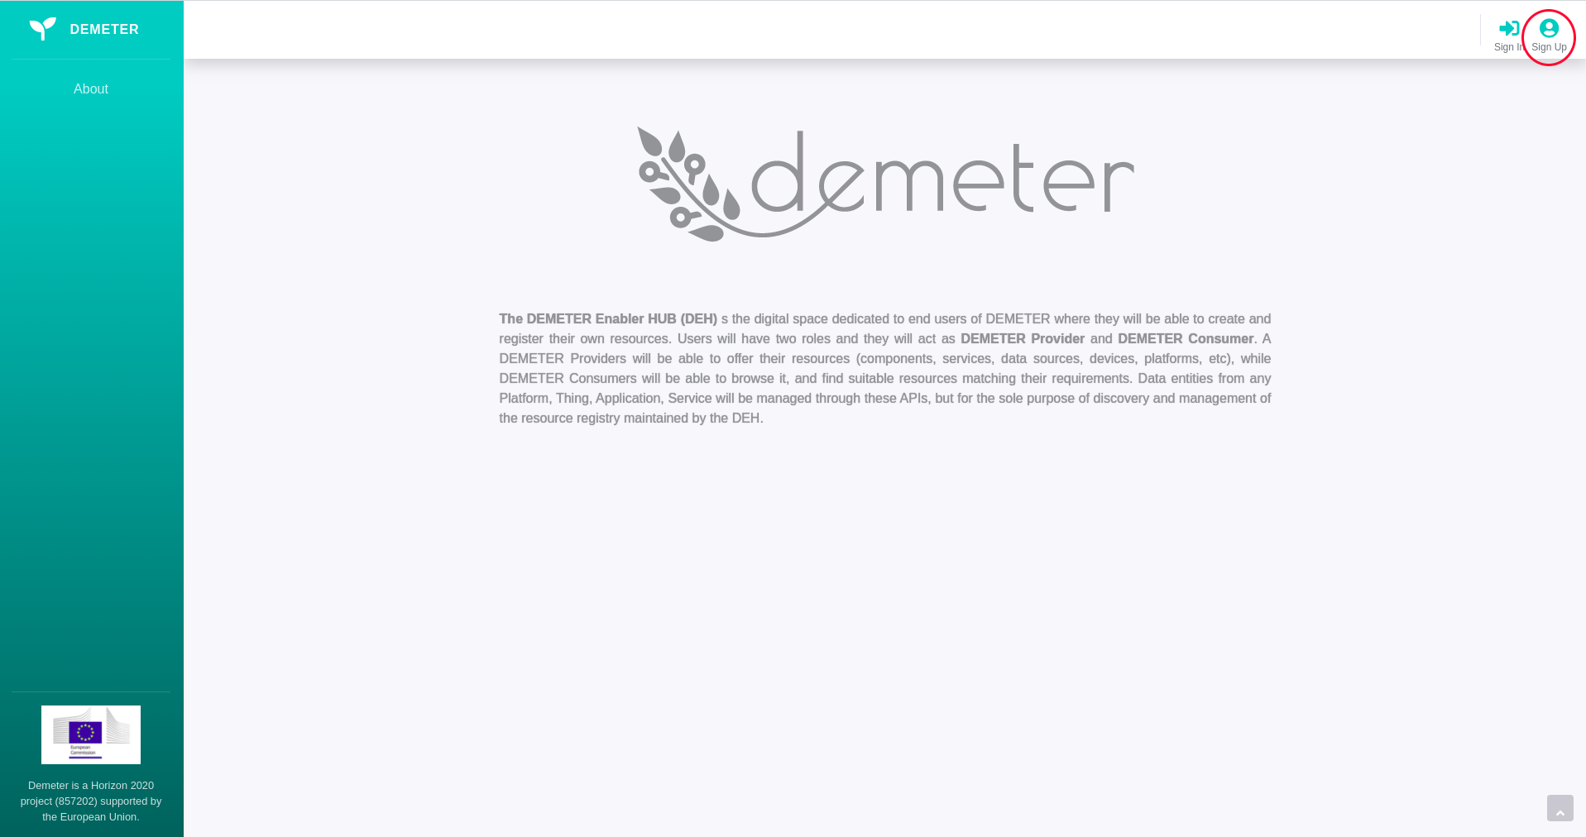

*Figure3. DEH Sign up*

You will be redirected to the Sign Up Page as shown in Figure 4.

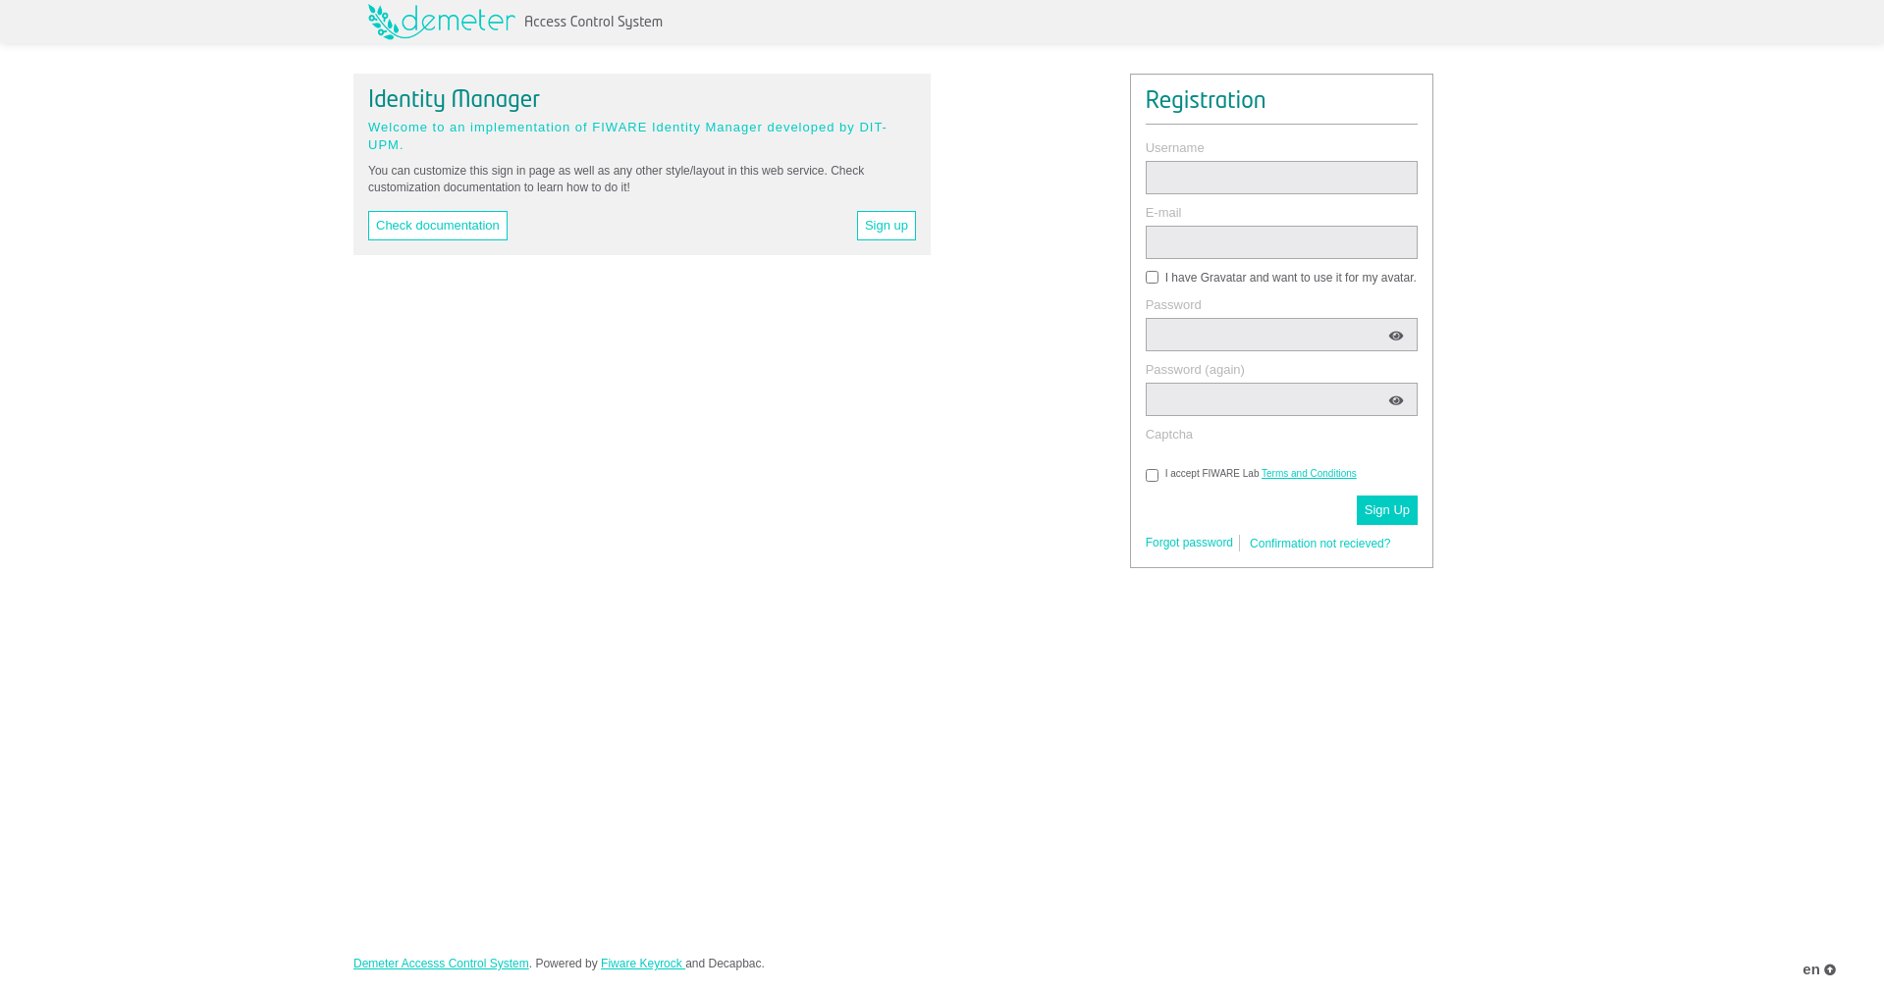

*Picture 4. DEH Sign Up Page*

2. Fill the form with the necessary information, and click on the Sign Up button as shown in Figure 5. You can check the documentation video for ACS registration in the following link: https://gitlab.com/demeterproject/wp3/se/components/acs/-/blob/master/videos/Demeter-user-signup_and_activate.mp4

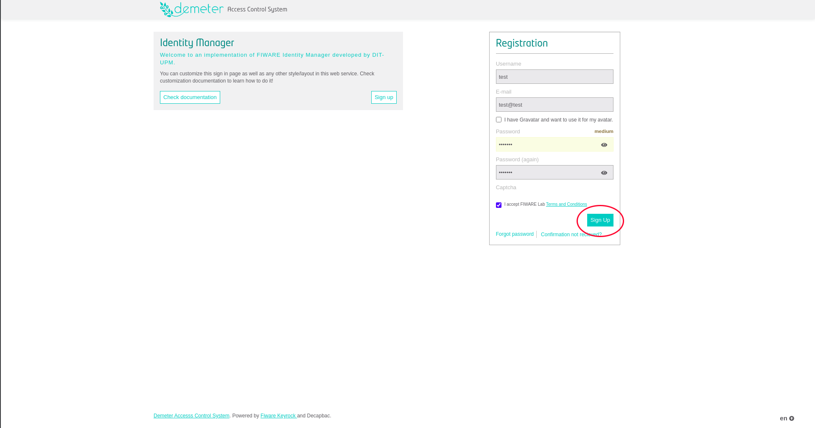

*Figure 5. DEH Sign Up Confirmation*

A confirmation email should be received in the email account registered. Please check the SPAM folder in case it has been filtered. In case any issue appeared with the account activation, please email [lmerino@vicomtech.org](mailto:lmerino@vicomtech.org) with Demeter ACS Account Activation issue, as well as email account and username of the registered account.

4. To gain access to DEH, please send an email to any of the DEH administrators: [Marko.Stojanovic@eng.it](mailto:Marko.Stojanovic@eng.it) or [gianluca.isgro@eng.it](mailto:gianluca.isgro@eng.it) with email account and username of the registered account and request the preferred role:

* DEMETER Provider: access DEH Resources list, publish and manage its own DEH Resources
* DEMETER Consumer: access DEH Demeter resource list

After the user get a confirmation email from DEH Administrator that DEH Role is assigned, you will be able to login to <https://deh.h2020-demeter-cloud.eu/> with previously registered credentials.

## Login

If you have enabled DEH Account, you can log in by clicking on the button Sign In in the upper right corner, after that you will get a form for user credentials, as shown in Figure 7.

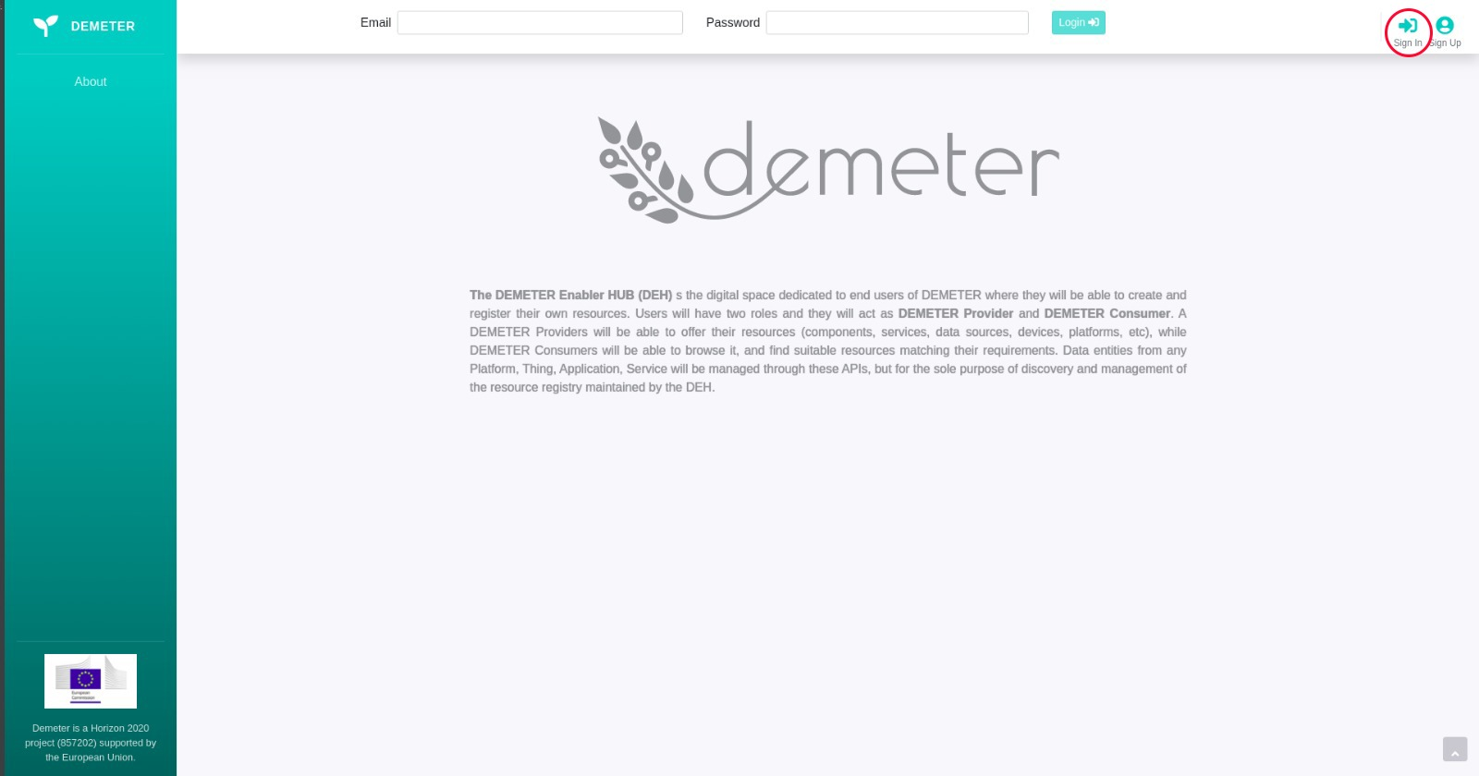

*Figure 7. DEH Login Form*

Fill the form with your email and password, and click on the Login button as shown in Figure 8.

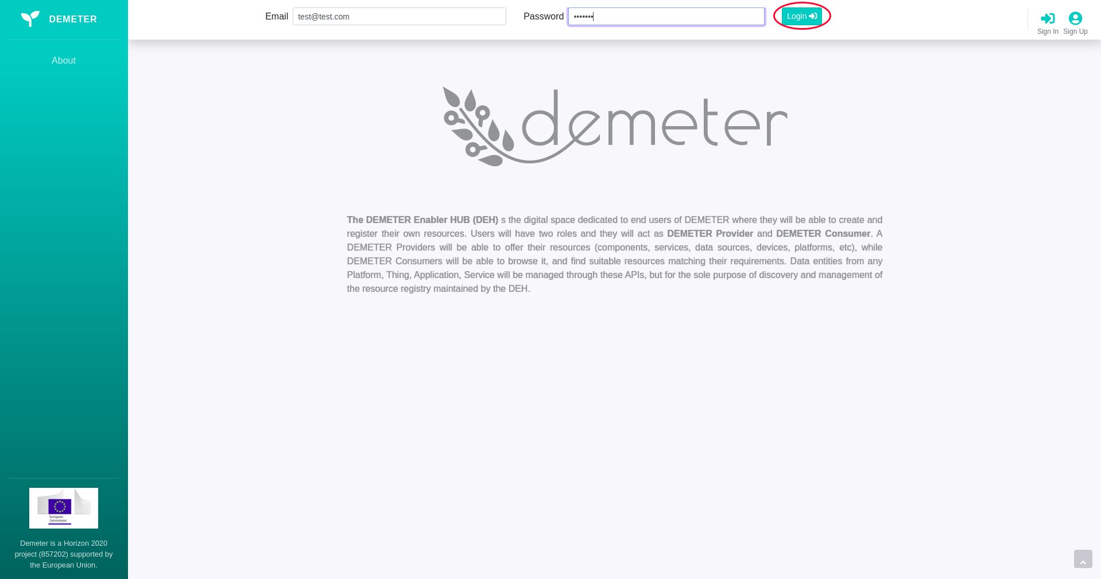

*Figure 8. DEH Login Confirmation*

After successful login, DEH will ask you to access your current location. Allowing this is mandatory if you want to use the advanced filter for searching nearby resources.

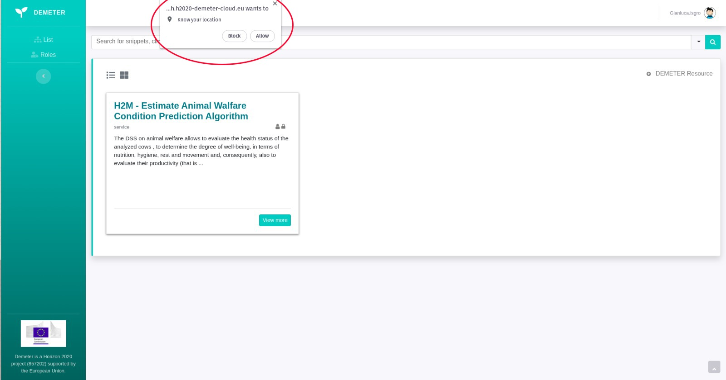

*Figure 9. DEH Location Access*

## Logout

At any time, you can logout from DEH, clicking on Account Circle next to the username in the upper right corner, and then clicking on the Logout button as shown in Figure 10.

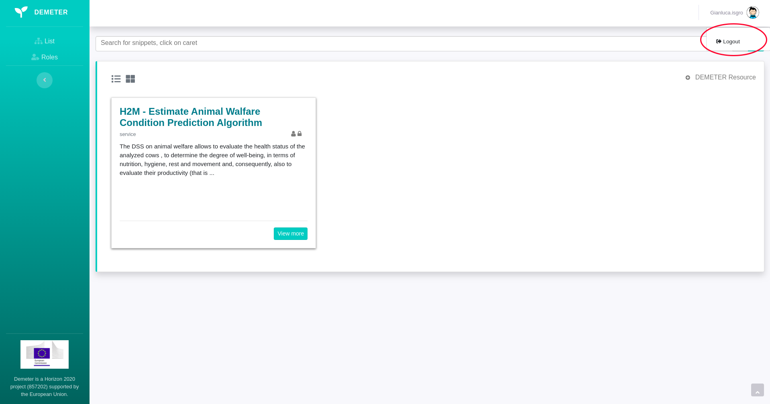  
*Figure 10. DEH Logout*

## Navigation through DEH

Figure 11. shows the Home Page after successful login, where all available DEH resources are displayed. You can choose among 2 different types of showing the DEH resources: **Card** and **List**. You can see in Figure 11. and Figure 12. how to switch between display types.

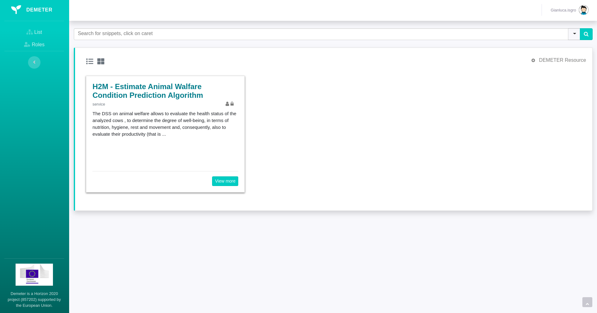

*Figure 10. DEH Home Page*

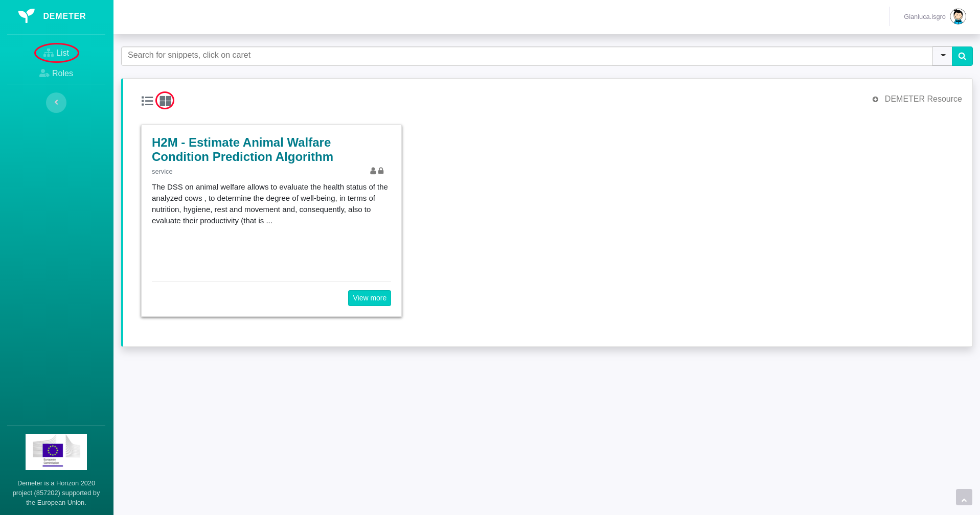

*Figure 11. DEH Resources Card View*

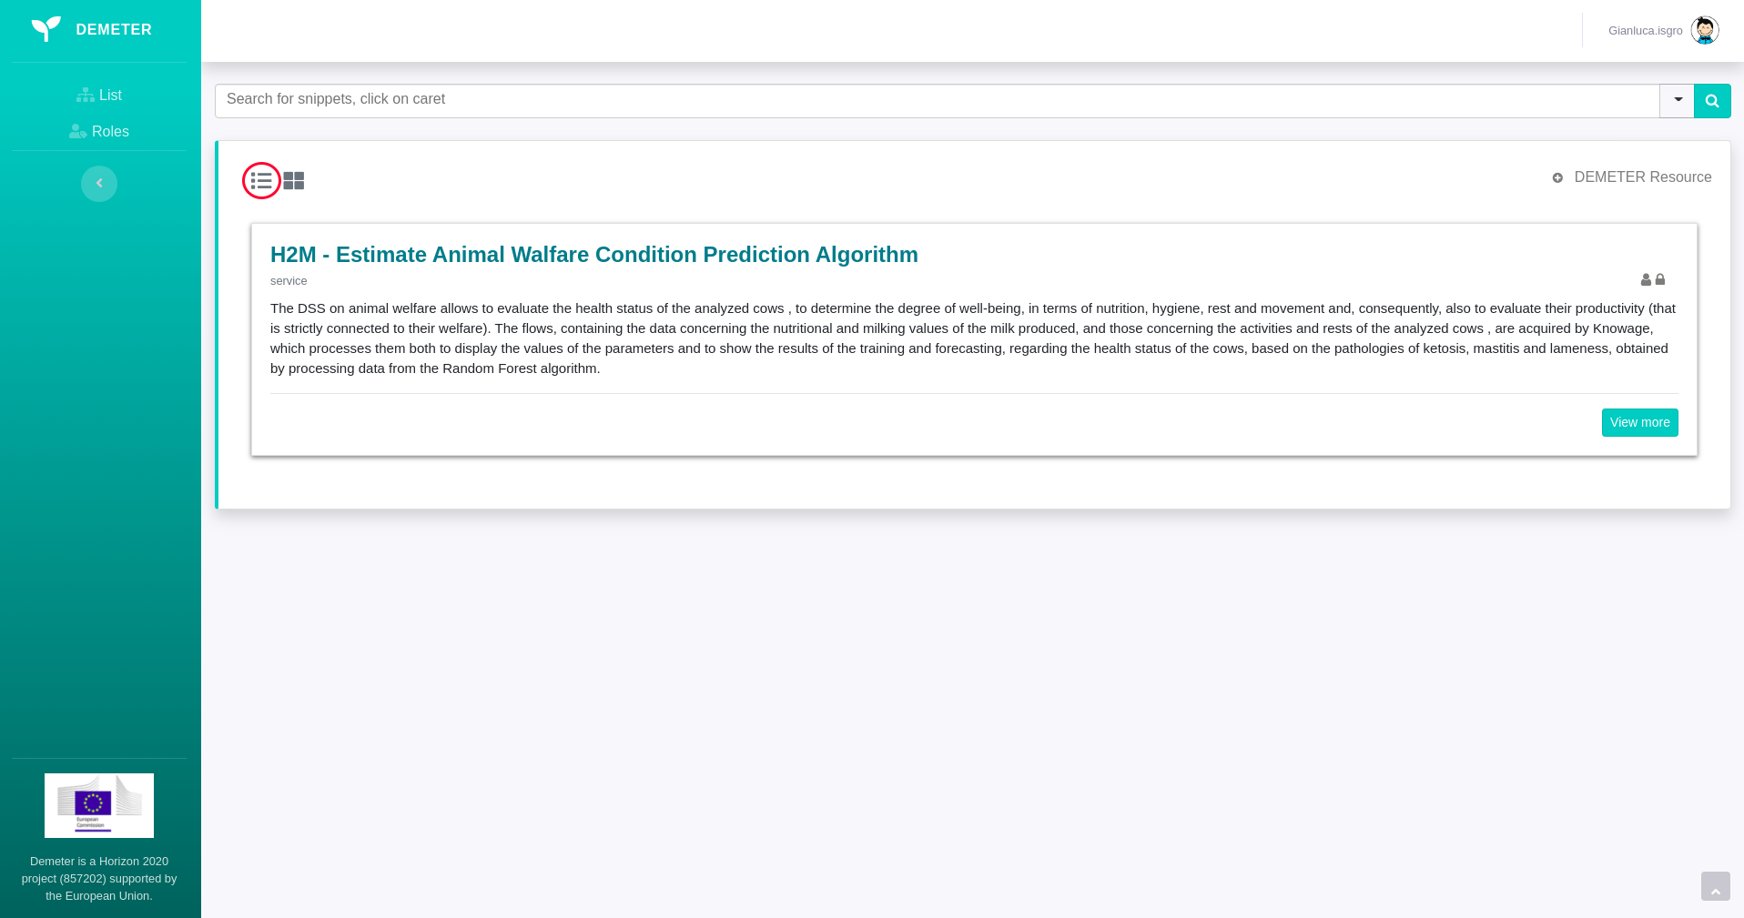

*Figure 12. DEH Resources List View*

Information about the assigned User Roles is available in the left navigation panel under the Roles button, as shown in Figure 13.

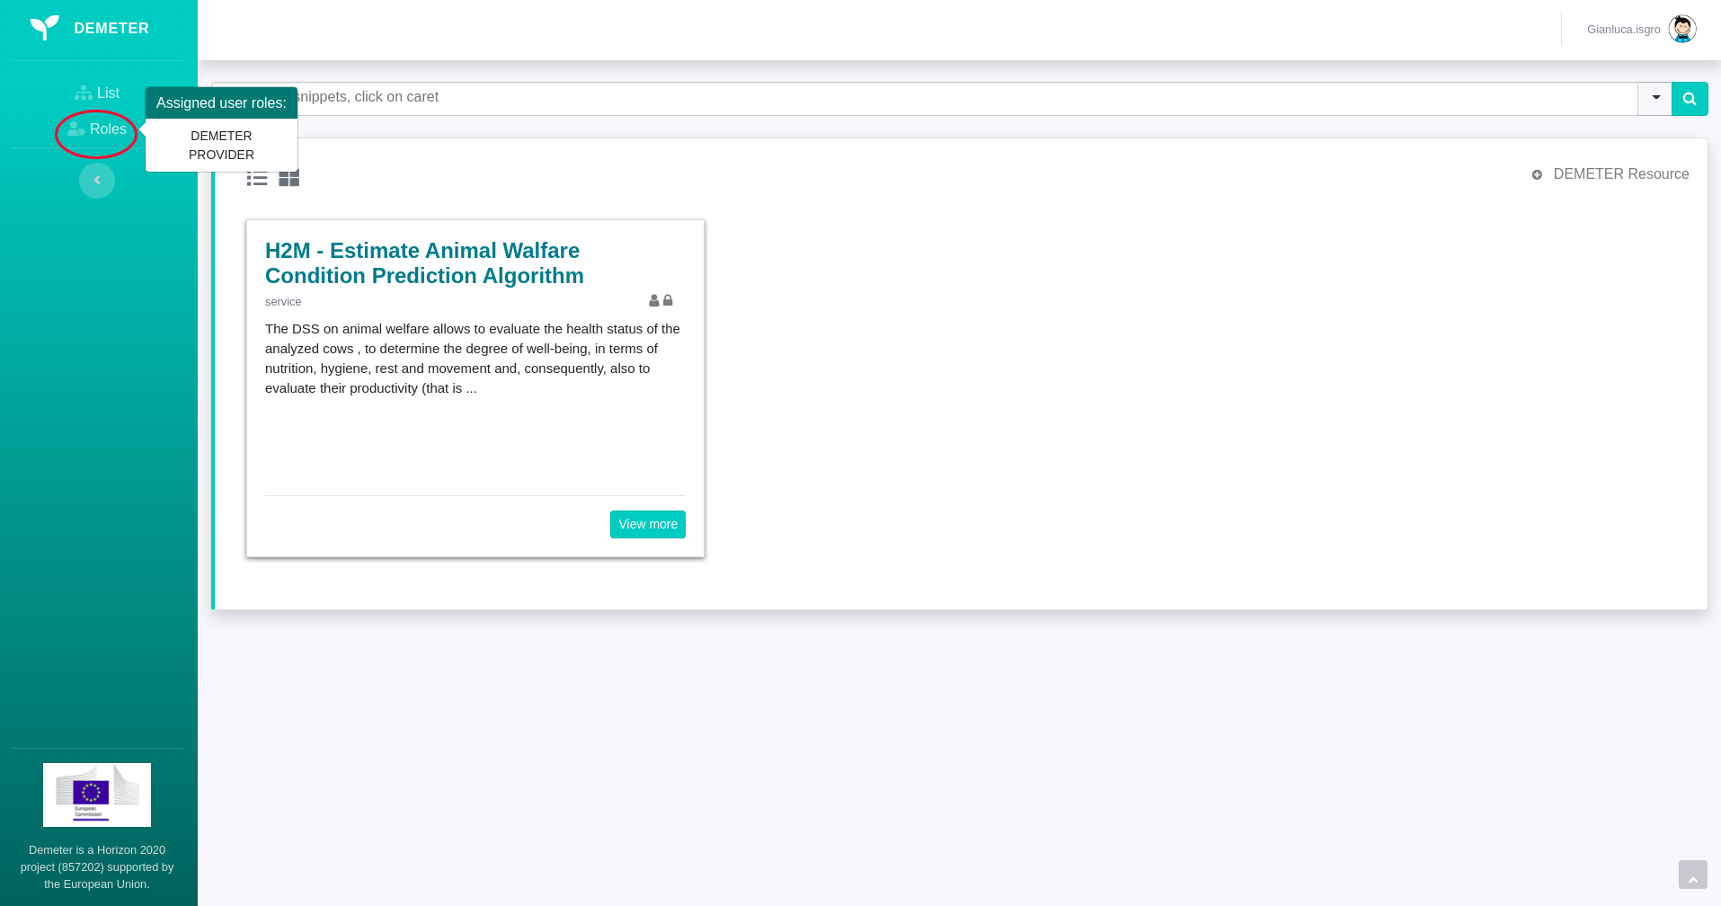

*Figure 13. DEH Roles Information*

You can use the Advanced Search option by clicking on the arrow below the Account Circle as shown in Figure 14.

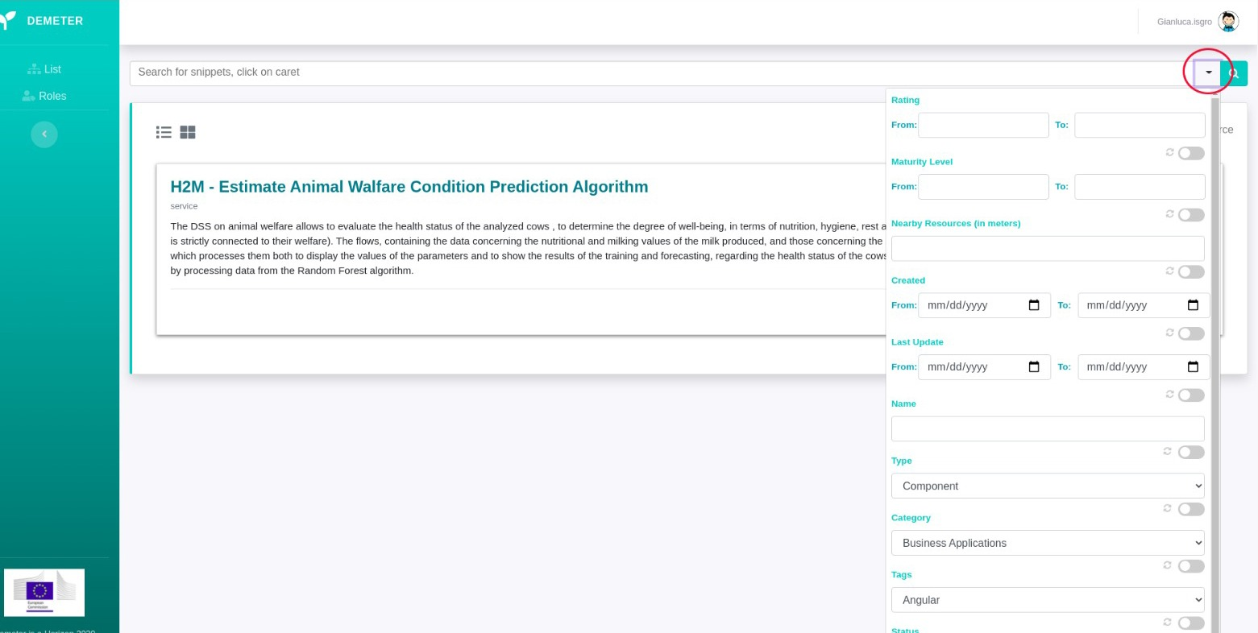

*Figure 14. Advanced DEH Resource Filtering*

You can apply next filters in Advanced Searching:

* **Rating From:** filters resources from a given average rating
* **Rating From – To**: filters resources by average rating in a given range
* **Maturity Level From:** filters resources from a given maturity level
* **Maturity Level From – To**: filters resources by maturity level in a given range
* **Nearby Resources (in meters)** - filters resources which are available in a given distance from your current location
* **Created From:** filters resources which are created from a given date
* **Created From – To**: filters resources which are created in a given range
* **Last Update From:** filters resources which are updated from a given date
* **Last Update From – To**: filters resources which are updated in a given range
* **Name**: filters resources which are having a given value in their name
* **Type**: filters resources by a given type
* **Category**: filters resources by a given category
* **Tags**: filters resources by a given tag
* **Status**: filters resources by a given status

If you want to apply some of the filters described above, you have to click on the button below the filter value, as shown in Figure 15.

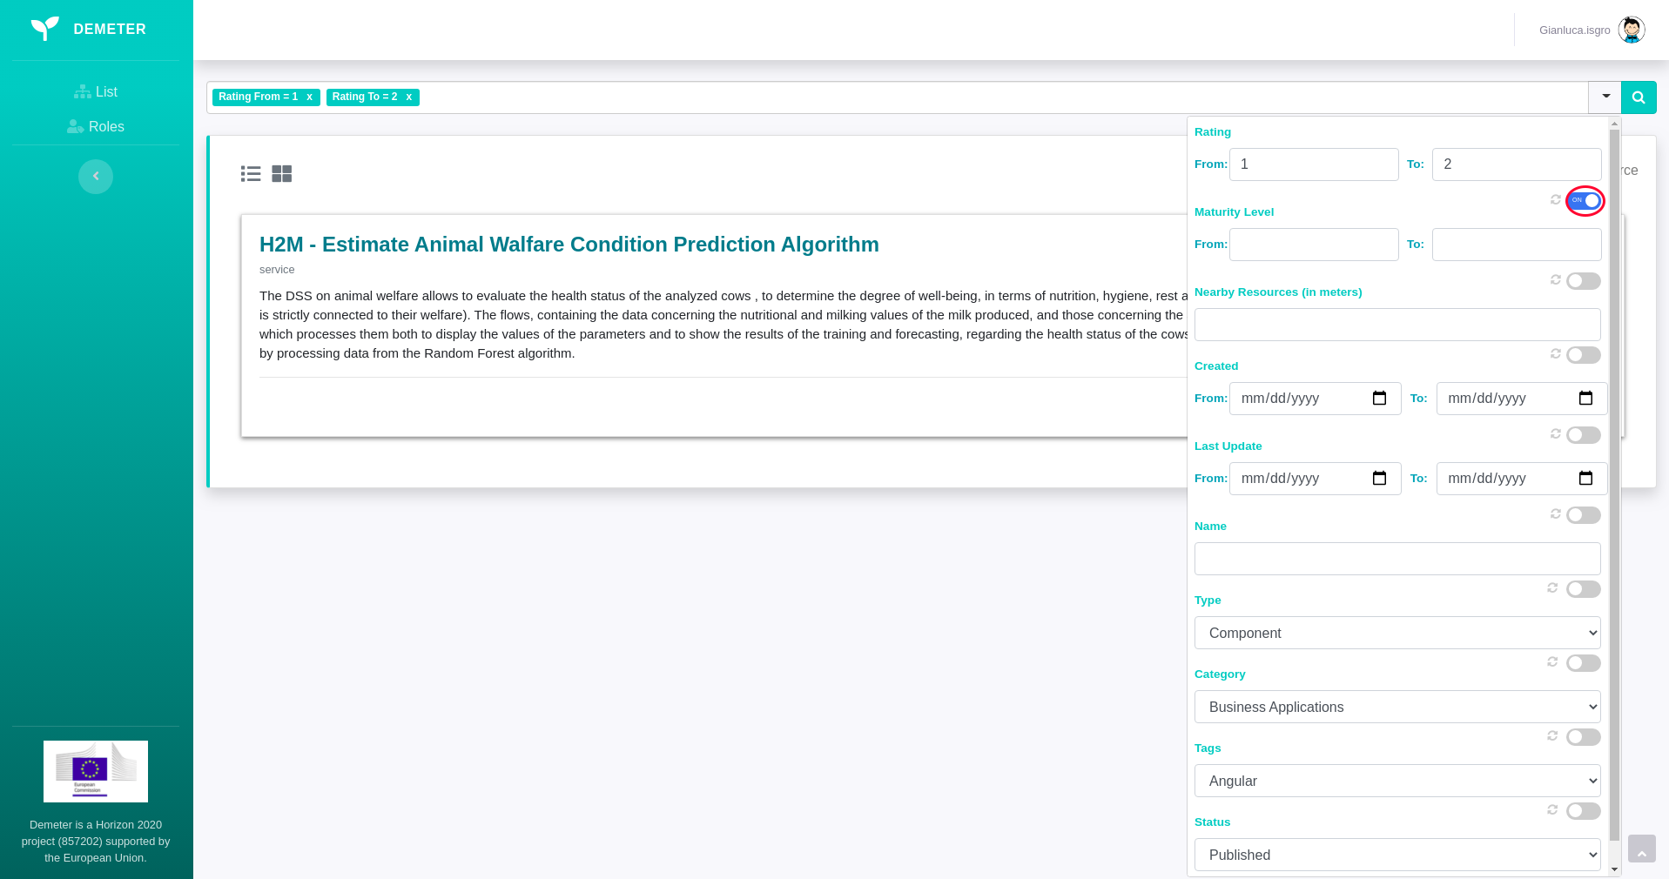

*Figure 15. Turn on advanced filter*

If you want to change the filter value, after editing, you have to click on the refresh button, as shown in Figure 16.

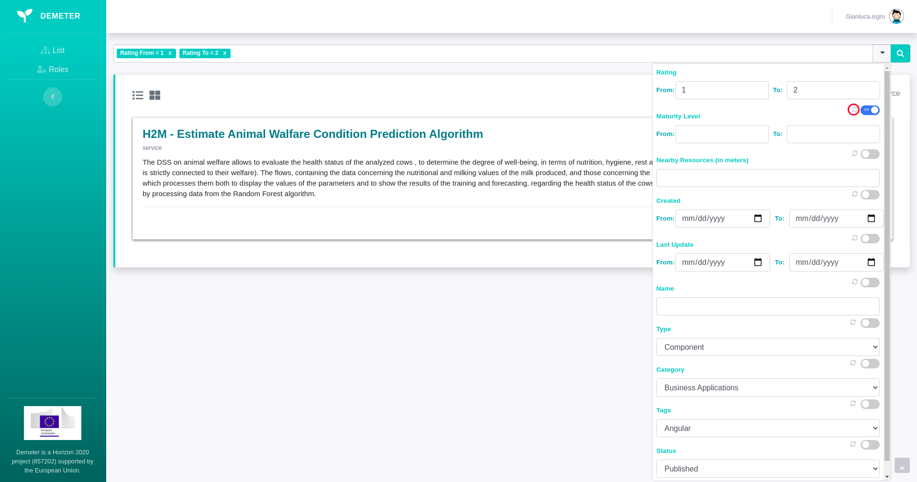

*Figure 16. Update values in advanced filter*

After inserting and turning on advanced filters, in order to apply them, you have to click on the search button, as shown in Figure 17, after which all DEH resources which are compliant with added filters will be shown.

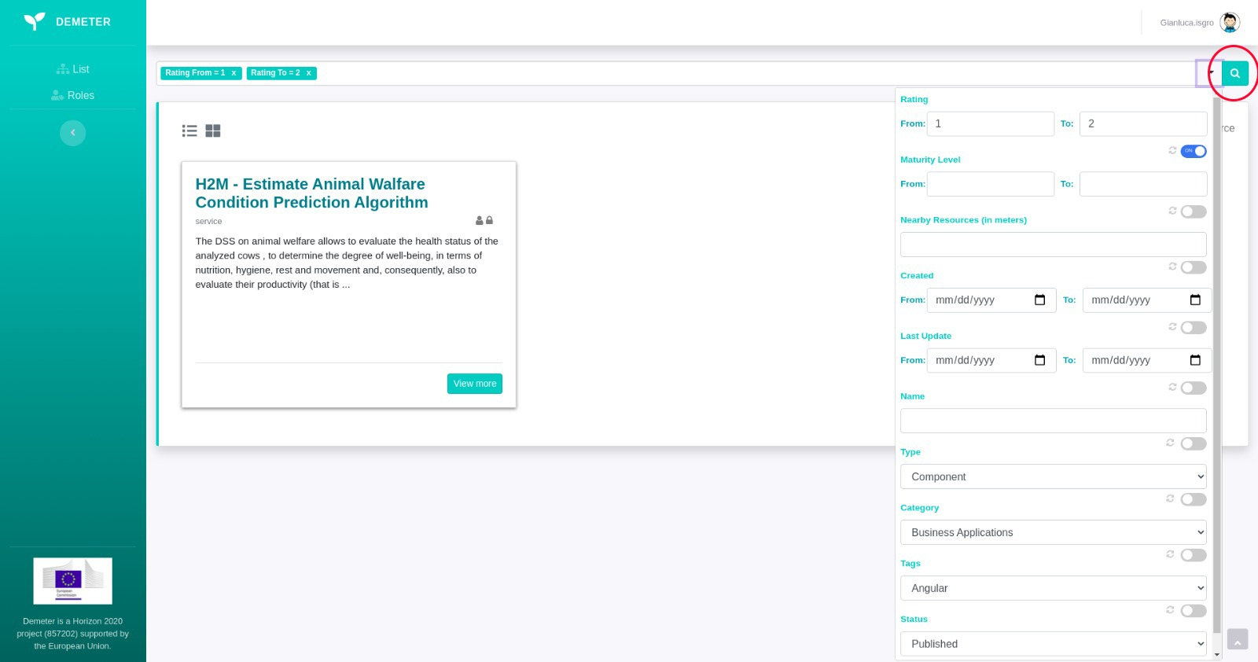

*Figure 17. Apply advanced filters*

You can get all DEH Resource information by clicking on the name of a resource or button **View more.** DEH Resource Details page is shown in Figure 17.

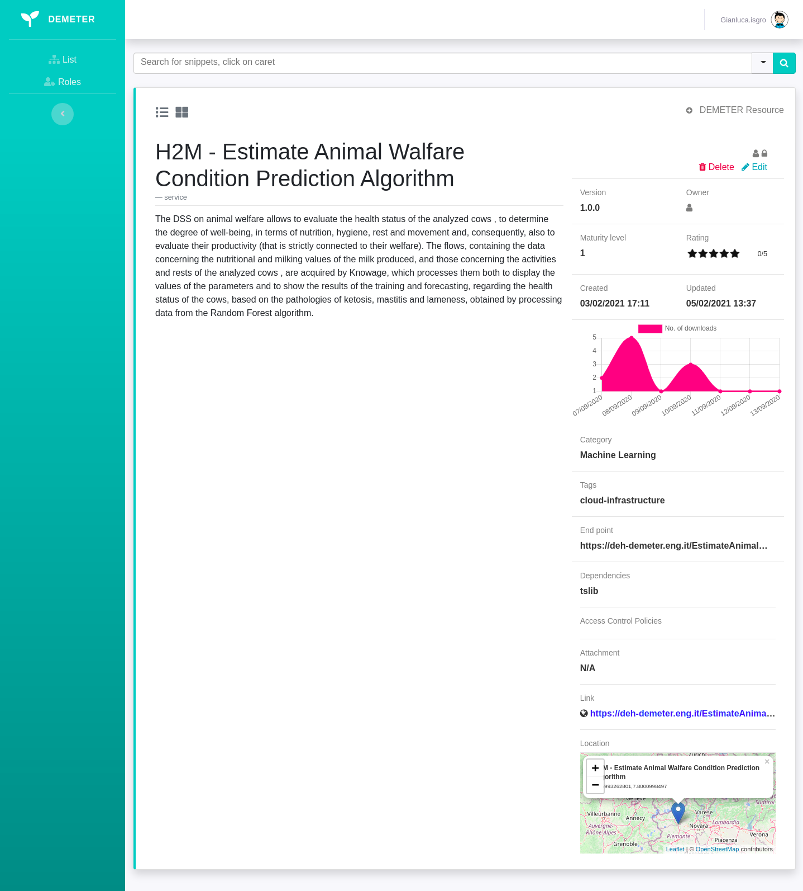

*Figure 17. DEH Resource Details*

## Add new DEH Resource

If your Role is **DEMETER Provider** you can add a new DEH Resource by clicking on button + DEMETER Resource as shown in Figure 18.

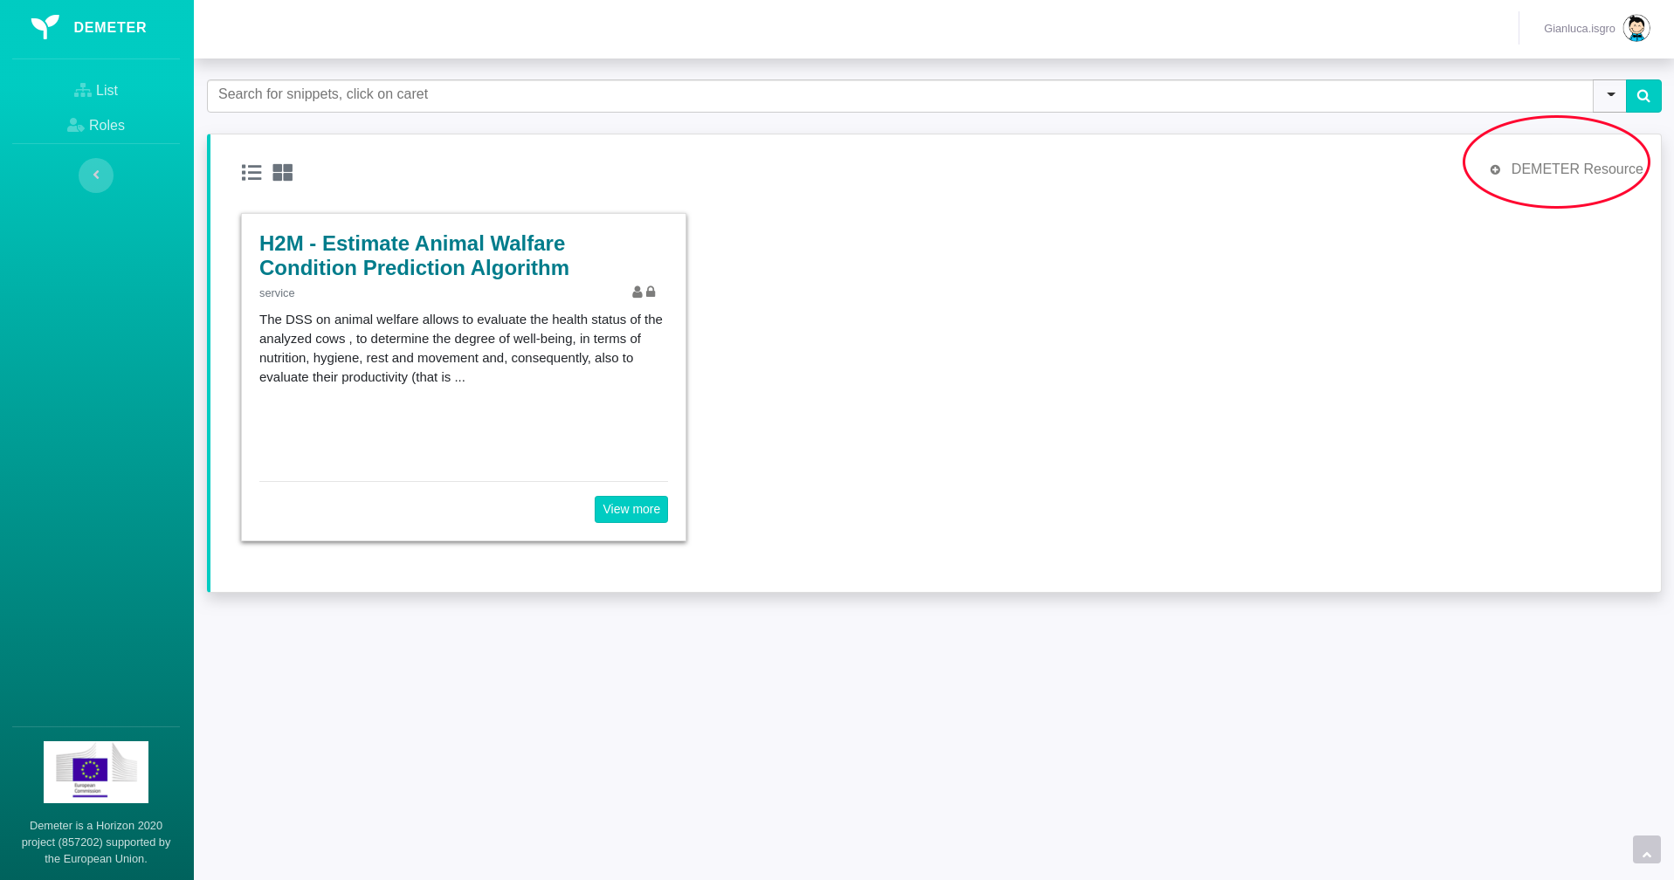

*Figure 18. Add DEH Resource*

After clicking on +DEMETER Resource button, the form with necessary information about the DEH Resource will be open, as shown in Figure 19.

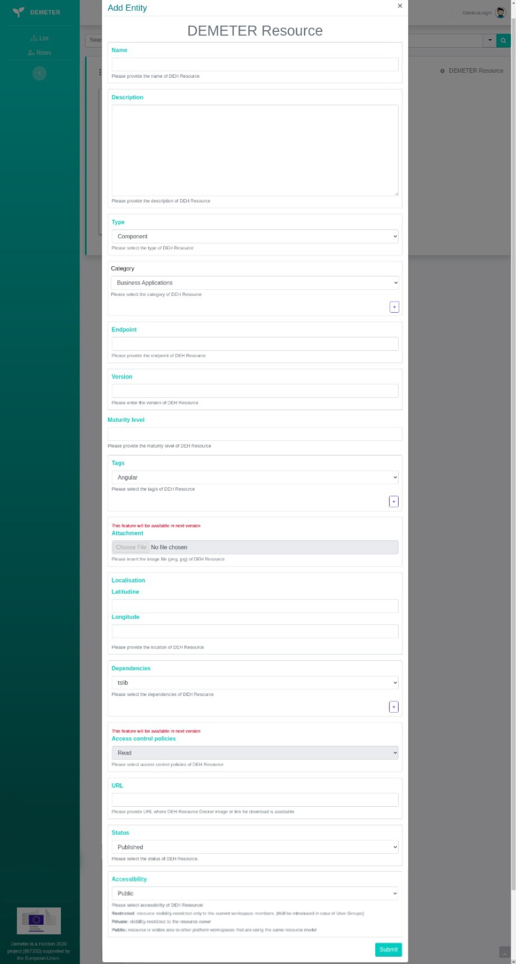

*Figure 19. Add DEH Resource Form*

After filling all necessary information about new DEH Resource, click on button Submit, and new DEH Resource will be stored.

## Edit DEH Resource

If you are the owner of DEH resource you are able to edit it. Editing DEH Resource is available by clicking the Edit button in right side on DEH Resource Details page, as shown in Figure 20.

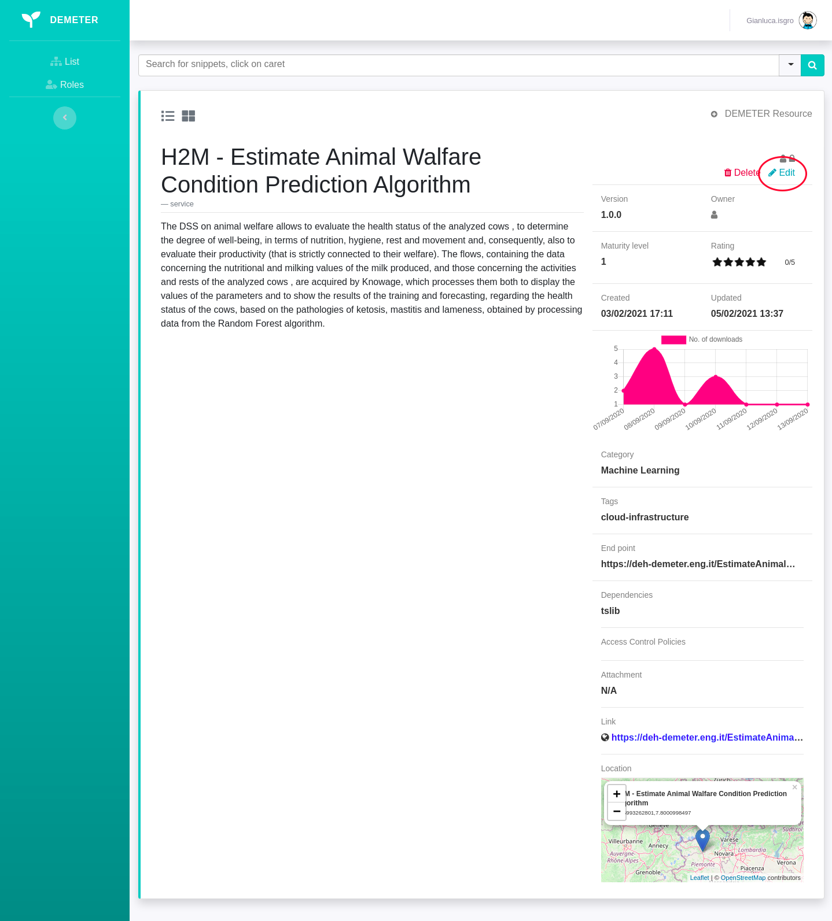  
  
*Figure 20. Edit DEH Resource*

After clicking on a button **Edit** button, as shown on Figure 21. The edit form will open, where you can change the information about a DEH Resource, then click on button **Save Changes**, after what changes will be stored.

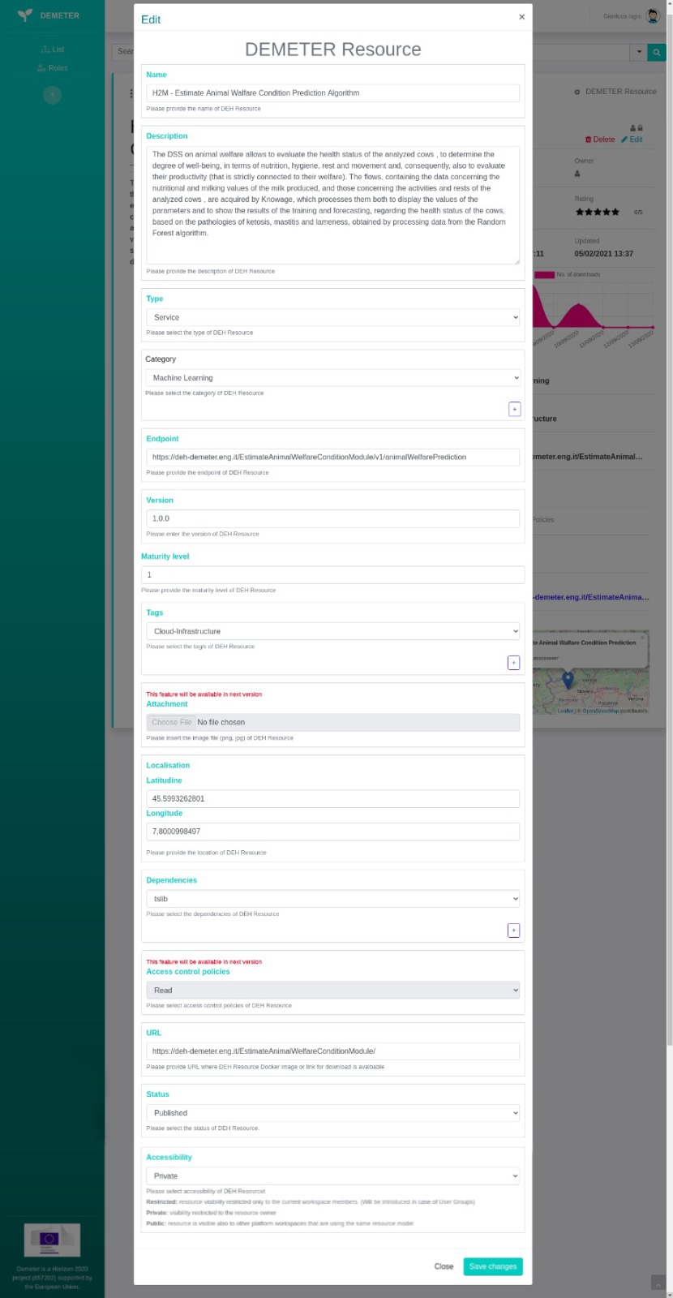

*Figure 21. Edit DEH Resource Form*

## Delete DEH Resource

If you are the owner of DEH resource you are able to delete it. Deleting DEH Resource is available by clicking the Delete button in right side on DEH Resource Details page, as shown in Figure 20. After what you need to confirm the action as shown in Figure 23, and DEH Resource will be deleted.

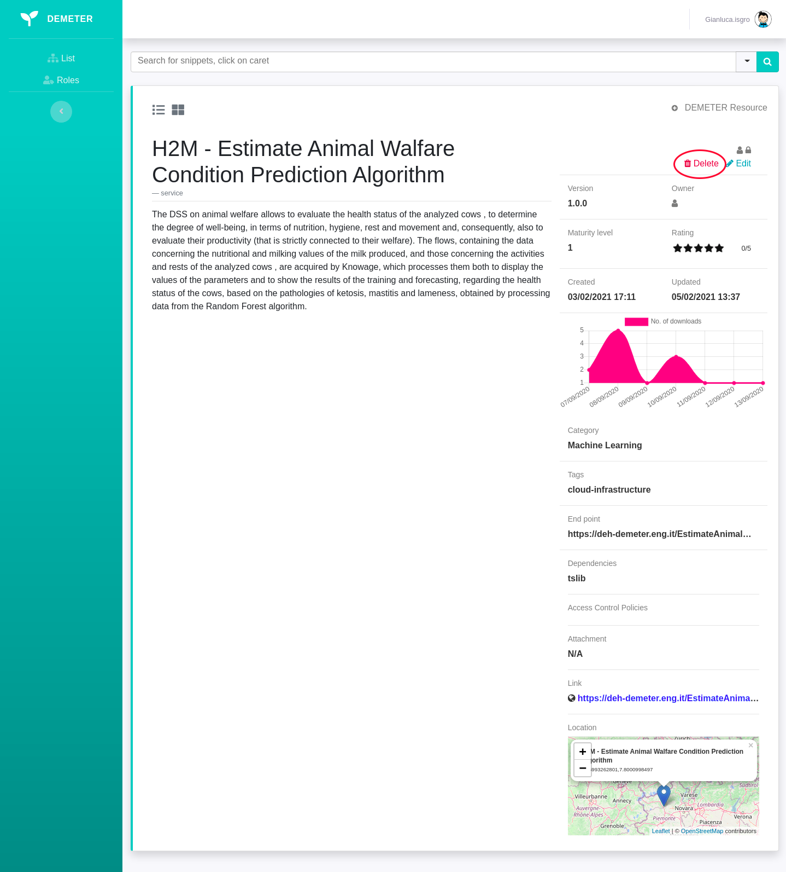

*Figure 22. Delete DEH Resource*

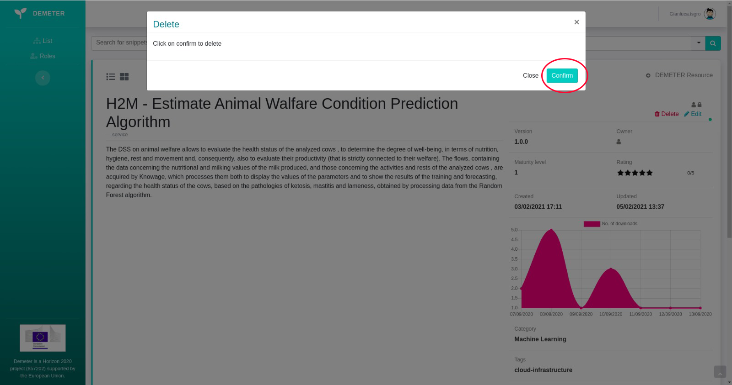

*Picture 12. Delete DEH Resource Confirmation*